**Provisional User's credentials**

To sign in to your PICMI application using a provisional user:

1. Go to [jobs.picmi.io/go](http://jobs.picmi.io/go)
2. Enter access code and name
3. Check “I agree”
4. Click Confirm And Start

Proceed through to job

For **Email** question answer <enter email address>

(note: the contract will be sent to this email address)

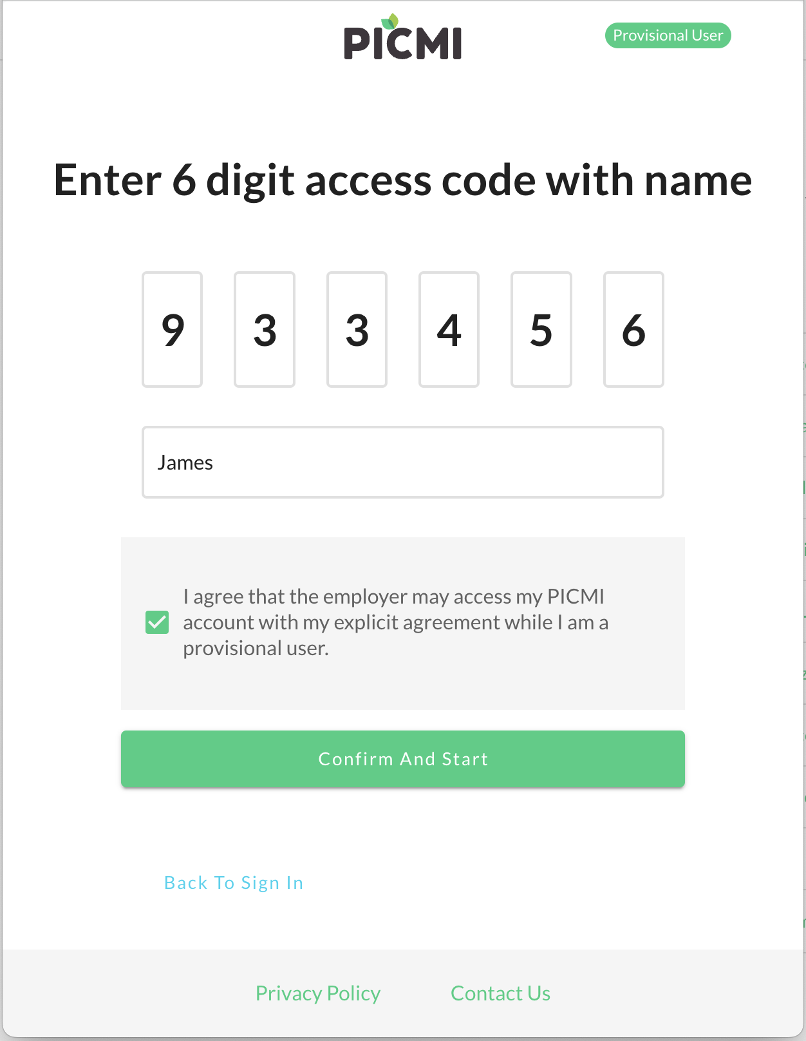

| Copy and paste the access keys and codes here |
| --- |